HOW TO INSTALL THIS APP

1) Download the APK

2) Click on Settings

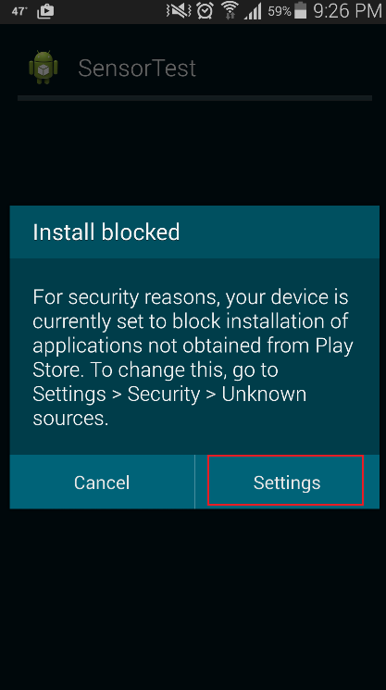

3) Go to Unknown Source and check he check box (This app is in a beta phase which means it is in testing phase so this needs to be done). No confidential data will be carried on using this device except your IMIE number or device id.

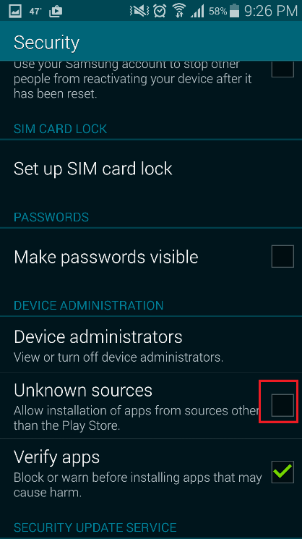

4) Click on Okay

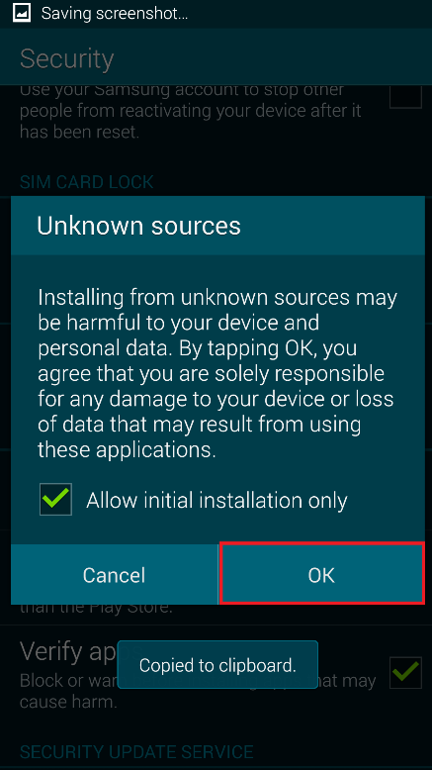

5) Click on Install

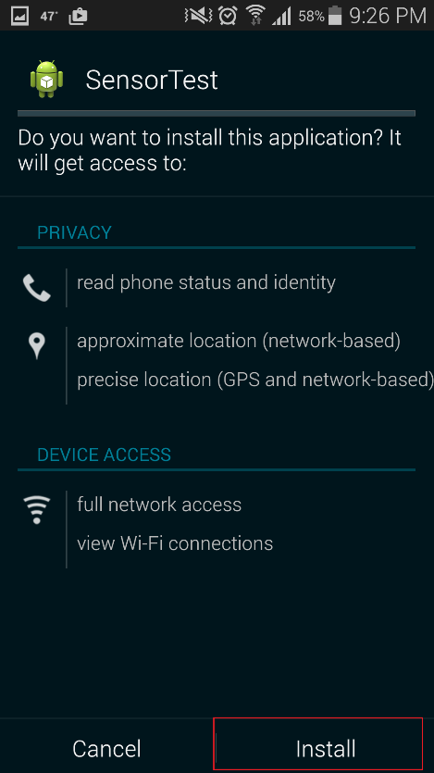

6) Click on open and this app is ready to be used

How to use this app

Make sure that GPS (location is on)

1. Click on Sensor Status

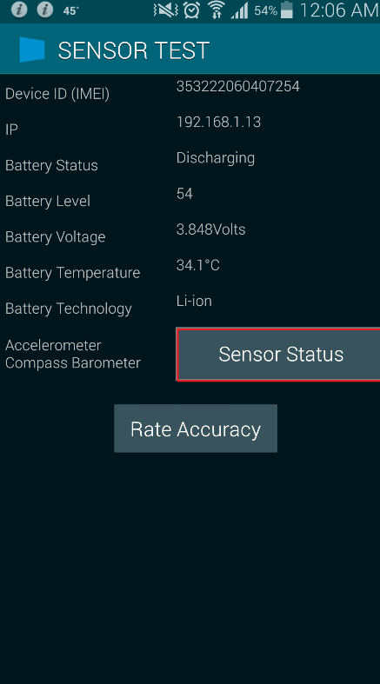

1. Click on record. Make sure again that GPS is on

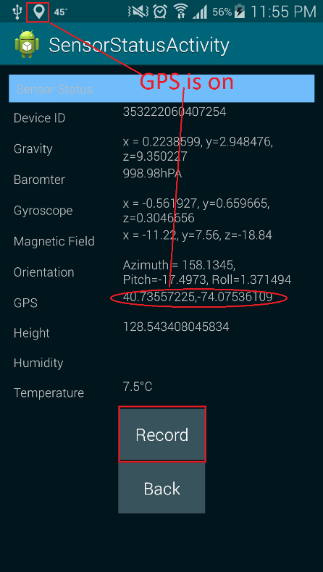

1. After 3 minutes click on stop record

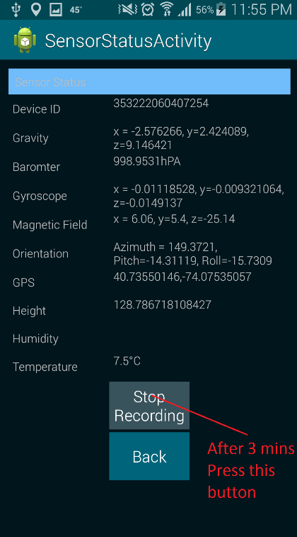

1. On notification window you will see success or failure notification

